Practical No.1

Aim: To study the Bitcoin whitepaper concepts and explore blockchain fundamentals (blocks, transactions, hashing, immutability, and consensus) through an interactive demo.

Blockchain Whitepaper: Bitcoin was introduced by Satoshi Nakamoto in 2008 through the paper "Bitcoin: A Peer-to-Peer Electronic Cash System". The main idea was to create a system where people could send digital money directly to each other without depending on a bank or central authority.Users communicate directly through a distributed network.

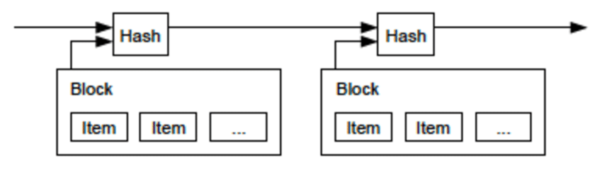
Blockchain Fundamentals:

Block: A blockchain is a distributed digital ledger that stores records or transactions in blocks, where each block is cryptographically linked to the previous block.

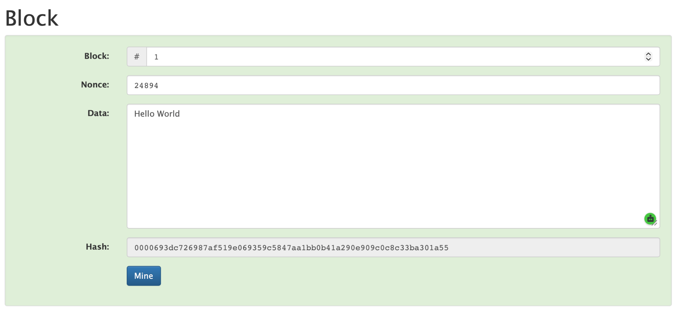
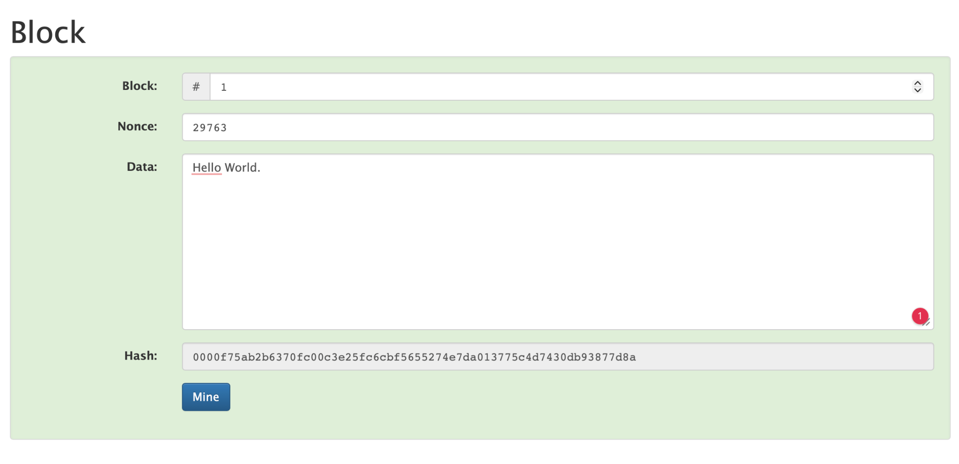
In Block hash changes as soon as data changes and that block becomes invalid unless mined again

Transactions: A transaction is a digitally signed record representing the transfer of value or a change of state on a blockchain.

Output:

